**Appendix 3 User Guide**

**User Manual - Java Program Clinical Management System**

**Content**

Understand the program

Using the program

Examples

**Understand the program**

The program is meant to be used for adding and storing patient, employee data to a database by means of a GUI system.

All the entered data will be stored on a local database and the information can be retrieved by using the GUI.

The users of this software have the option to add, remove, search and edit the data they wish to handle.

**Using the program**

Running the program through the IDE will start the application.

**Secretary add a patient**

The secretary will use the current GUI to fill in the required fields and then click on the add button to save the entered data to the local database

***Figure 1 Adding a patient with the GUI***

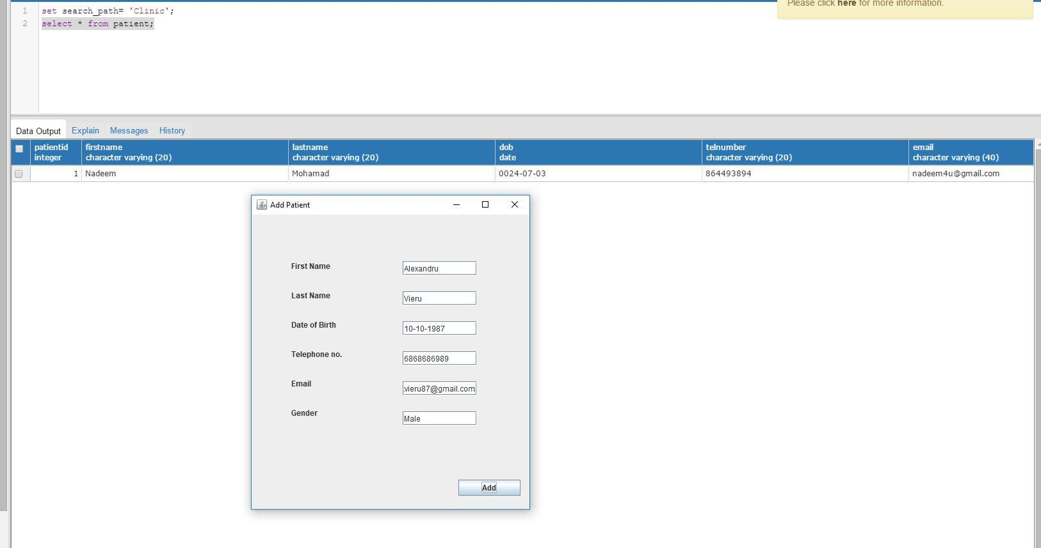

***Figure 2 Patient added to the database***

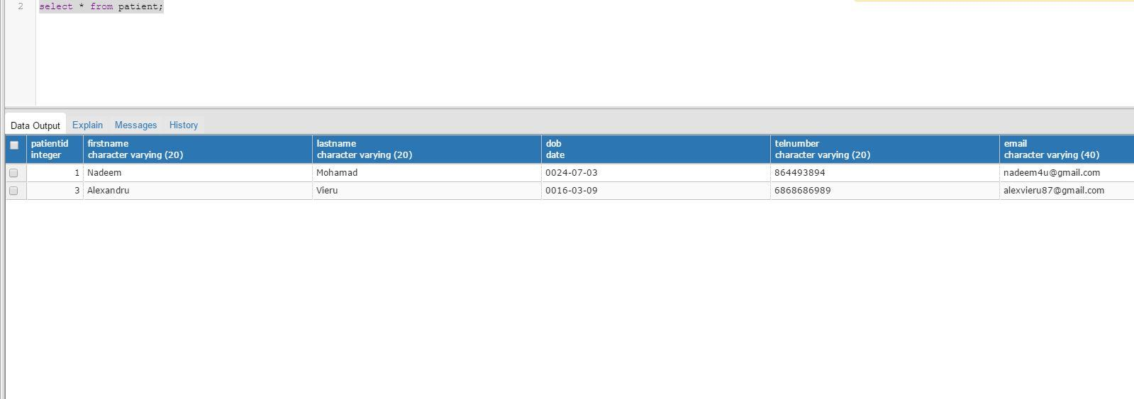

**Secretary removes patient**

The operator uses the GUI to remove a patient form the list. First the desired name is entered in the search box, and then the user presses the search button to find the desired patient. The system returns a name and by clicking remove button, the operator will remove the selected item.

***Figure 3 Removing a patient***

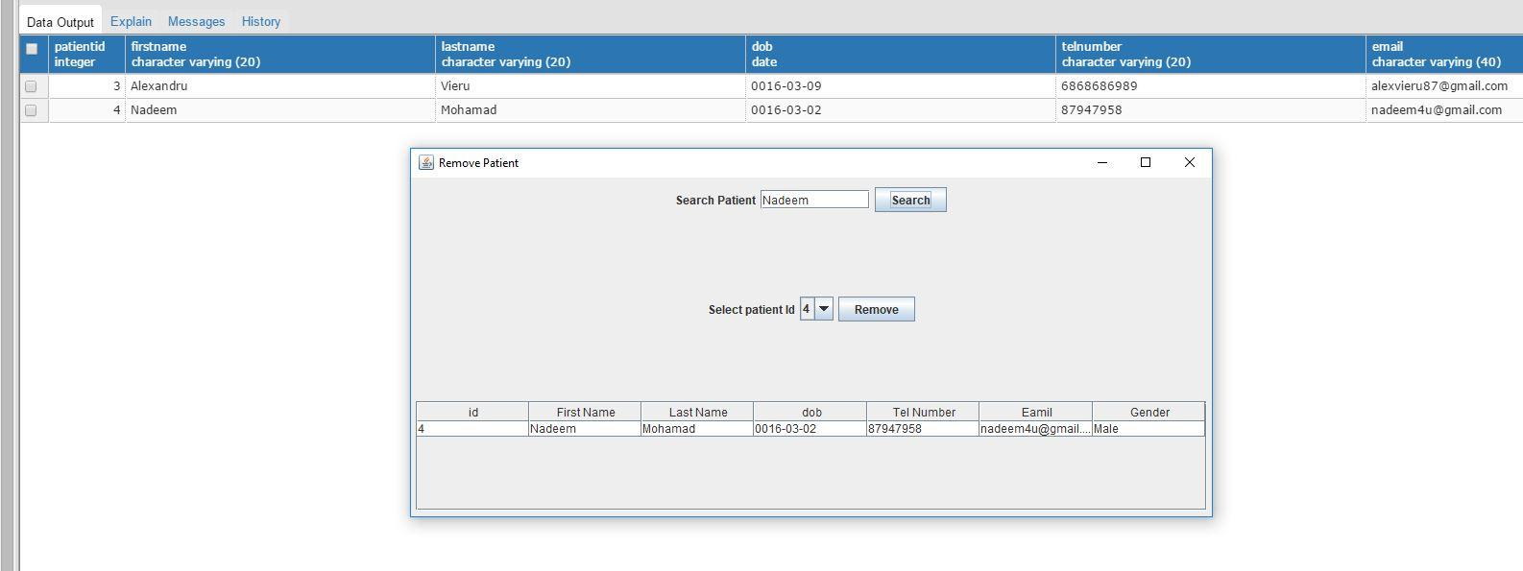

***Figure 4 Patient removed from the database***

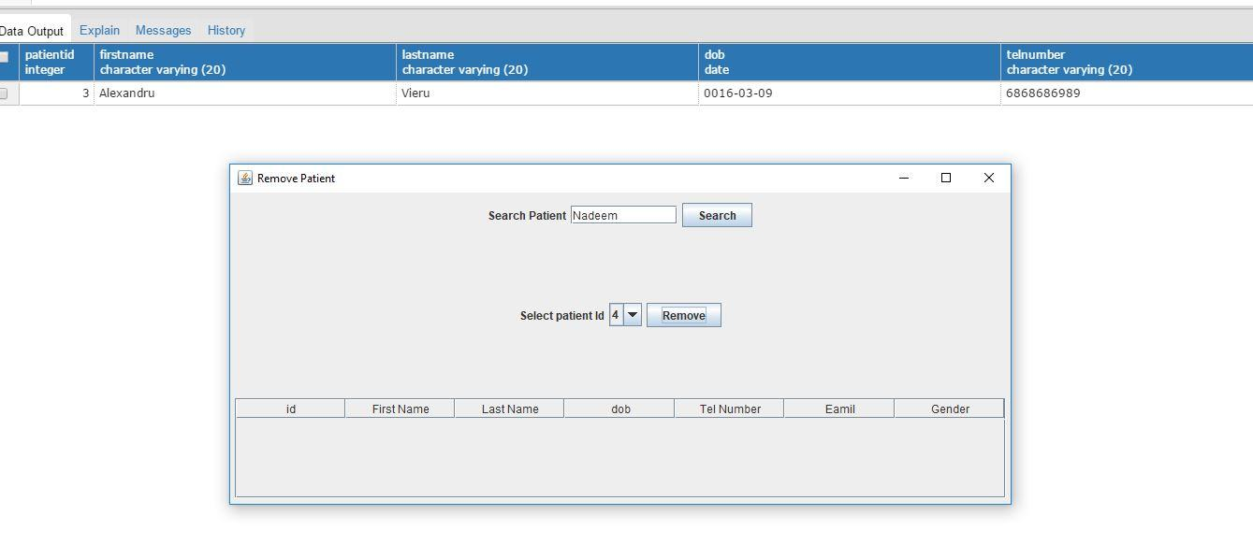

**Secretary searches for patient**

The operator searches for the patient by first name. Secretary enters the desired name and clicks the search button. This is like the remove patient case.

***Figure 5 Search for patient***

A screenshot of a social media post

Description generated with very high confidence